

**Logo:**



**Color code:**

Top: #2aade2

Bottom: #91fcfe

**Management Team:**

1. The Founder and Managing director **Mr. Fenwick B C (MBA)**

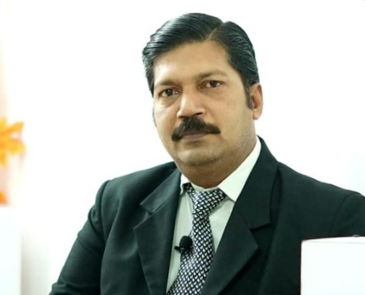

1. The Director of Administration – **Mr.Arjun.M.K** (B.E Mechanical)

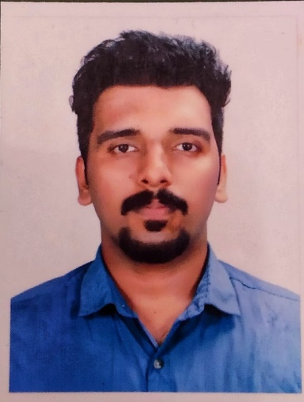

1. The Director of Finance – **Mrs. Gracy Forte**

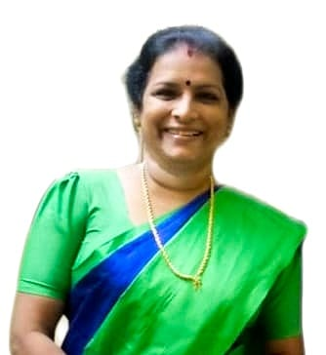

**Marketed and promoted By SHR Team:**

1. founder and chairman of SHR - **M. M. Ashiq**

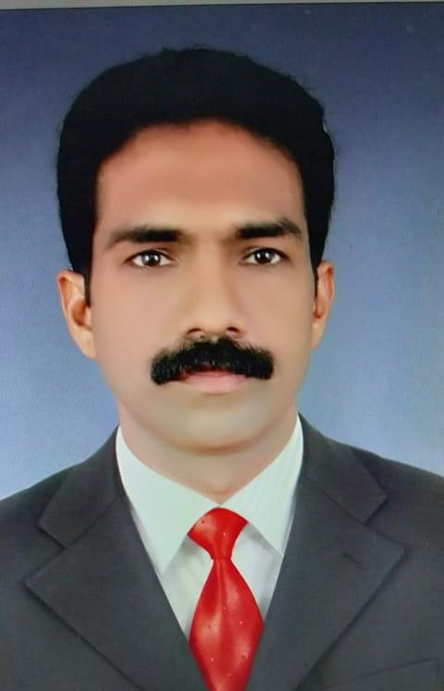

1. The General Secretary of SHR – **DR. P. K Vijayappan**, (Rtd. Supt. Of Police)

**Advisor – Brahma Shree Dr. Raja Krishnamoorthy**

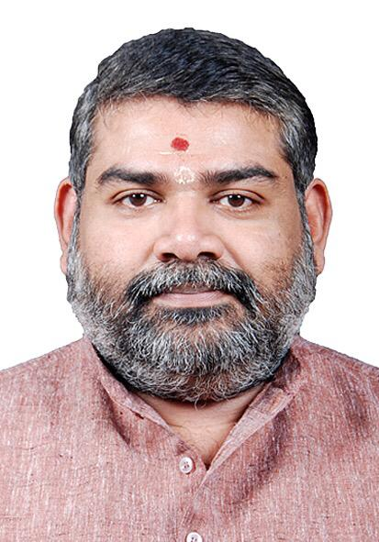

**Marketed and promoted by SHR**

**SHR logo:**

